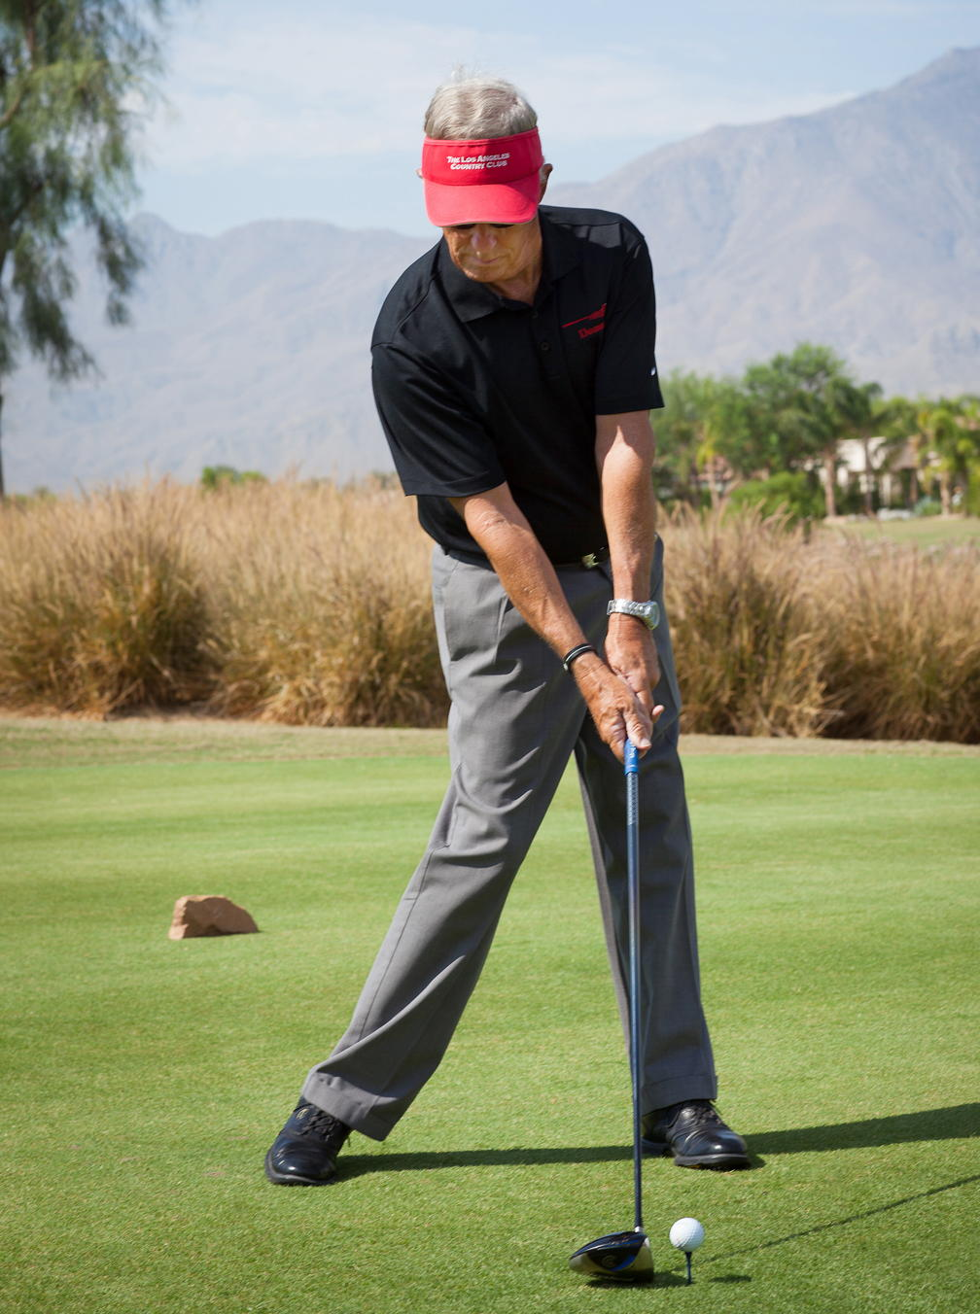

**The Zone Golf Academy**

Info@ZoneGolf.com

(951) 200-9880

ZoneGolf.com

**The Mental Game Toolkit**

ZGA’s Mental Game Toolkit provides the tools to think your way to better scores. It is a primer for the mental game. The mental game for the golfer is the learning, applying, and retaining sports psychology concepts as applied to the preparation and playing golf.

This toolkit will not require additional driving range time nor does it require the strength, balance, and coordination of a person like Tiger.

The following are some topics that improve your golf performance:

1. 'Bullet-proof' pre-shot routine
2. Proper post-shot routine
3. Establish personal par to have more fun.
4. An understanding and application of mental imagery or visualization just like Brad Faxon, Fred Couples, and other Pros use.
5. An understanding of your ‘on board feed back system’ or proprioceptors to generate the feel and muscle memory for correct body pivot, swing path, etc.
6. Awareness and mindfulness in practice and play.
7. How to generate an internal ‘climate’ to facilitate getting into the zone and staying there.
8. Implement a swing change without losing confidence.
9. Understand and improve motivation, confidence, clarity, and consistency EACH day.
10. Manage distractions on and off the course.
11. Manage anger on and off the course.
12. Use of key practice and personal measurements to evaluate progress, maintain focus, and build confidence.
13. What to do prior to a tournament.
14. How to warm up you mind, body, and technique prior to playing.
15. Disarm the negative self-talk or inner critic and replace it with positive self-talk.
16. Focused concentration to diffuse pressure.
17. Biofeedback devices to ‘measure’ your ability to concentrate.
18. Proper preparation prior to the pre-shot routine.
19. Refine a pre-shot routine to provide mental clarity and trust.
20. Coping skills to handle adversity.
21. Maintain a consistent blood sugar level and stay hydrated on and off the course
22. Relaxation techniques and stress management for use on and off the course.
23. Evaluation of fears, worries, and doubts and how to properly manage them.
24. How to control your thoughts and become a positive, optimistic person.
25. How to eliminate the ‘Win or Worthless’ mindset.
26. Explanation and cure for why your practice swing looks/feels perfect, and the real swing does not.
27. How to recover from a loss of feel and touch in putting and short game.
28. Learn failure (or non-perfect results) means that there was a failed event. People are not failures, only events can be failures.
29. How to never choke again
30. How to focus on the process instead of outcome.
31. Relieve yourself from 1st tee jitters.
32. What to do when ‘it hits the fan’.
33. What a golfing persona is, and how it protects the player’s confidence- what to do, how to act, and what to say before/during/after a good round, bad round, or average round?
34. Become a mastery golfer instead of an ego golfer.
35. Take a ‘vacation’ while on the course to add to your clarity.
36. How to use simple methods to change a habit.
37. A perspective that allows you to make every putt.
38. The top 5 course management thoughts to save strokes without additional practice: when to go at flag, pre-accept all outcomes, use accurate yardages for clubs, be an actor when hitting challenging shots, and focus on fairways/greens.