ZGA Golf Conditioning Program
The Zone Golf Academy is pleased to launch the new ZGA Golf Conditioning Program, with two options to decide on depending on your objectives, budget, and time allocation for conditioning.
The ZGA is well known for improving golf performance by addressing a golfer's needs in the 3 main areas:
  - Golf Technique
  - Mental Game and The Zone
  - Golf Conditioning
Since 2004, the ZGA has handled the first two areas in-house but the Golf Conditioning efforts were outsourced to local PGA Tour trainers with TPI and/or CHEK certifications; trainers that Lee Woodard has personally used. This option is still available if the client desires that.
But the ZGA now offers the detailed evaluation of the client's conditioning needs given their swing weaknesses and provide a detailed conditioning program for the golfer to follow- better swing evaluation for maybe just 10% of the cost of an outside conditioning provider.
What is unique about the body motion for the golf swing?
The golf swing uses all three planes of upper body movement:
1. Forward-bend ( or sagittal)
2. Side-bend (or frontal)
3. Rotational (or transverse)
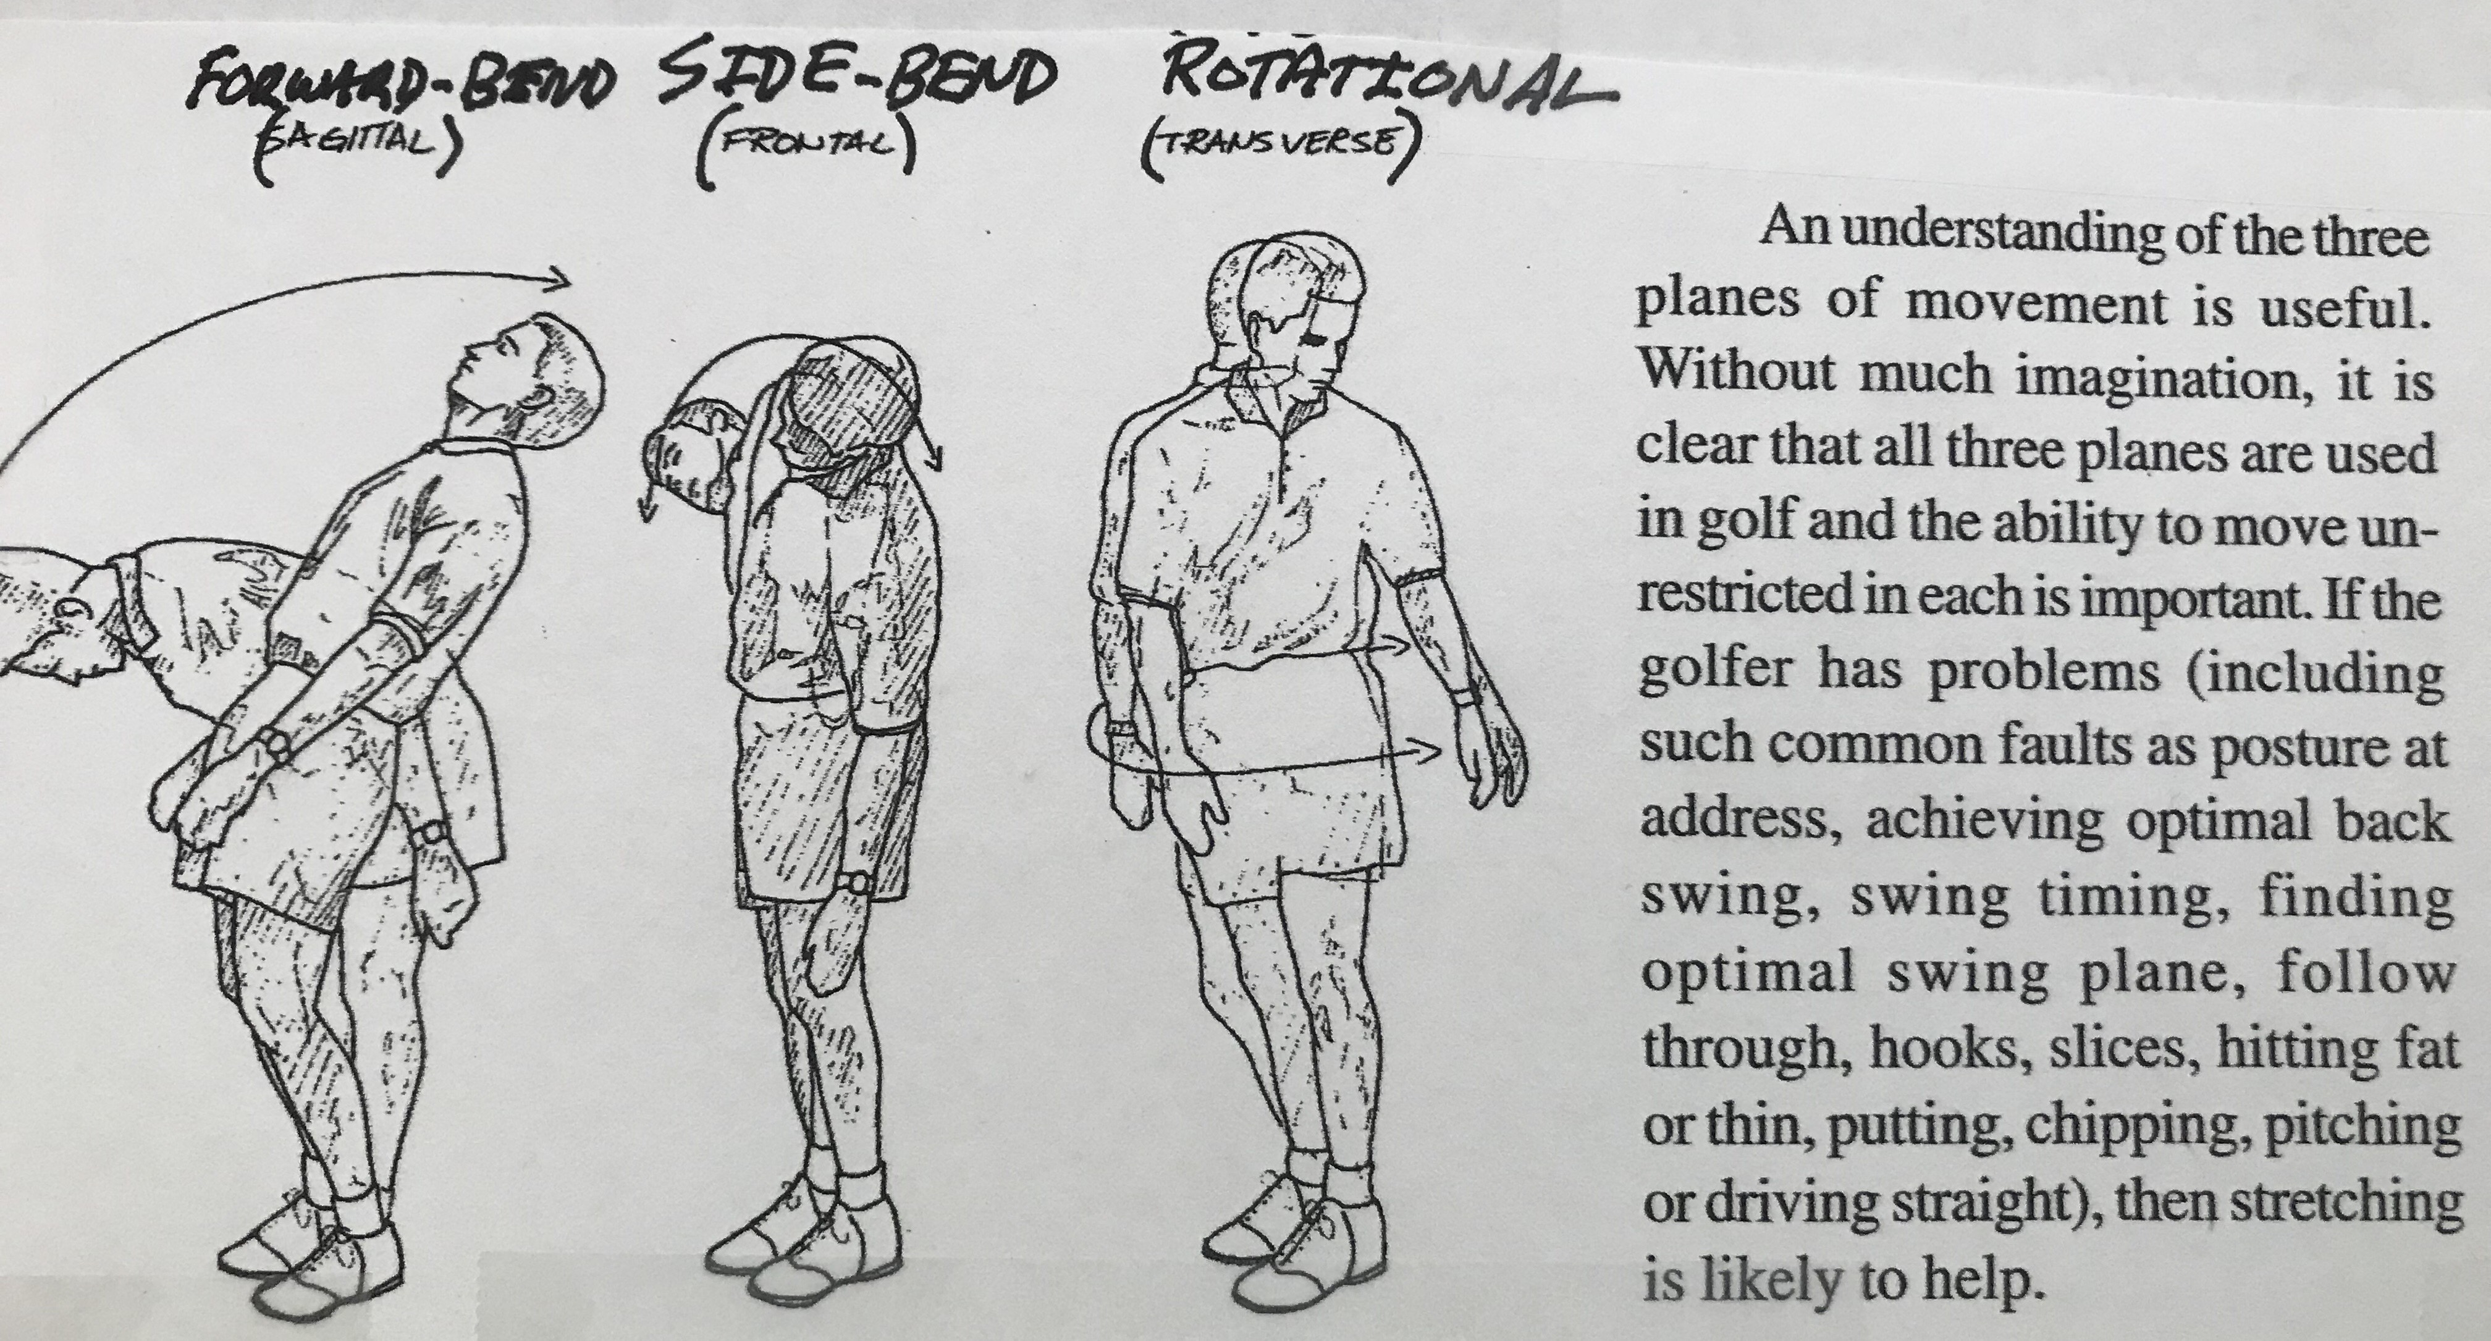

The golf swing motion is unique and is a bit complicated because it blends motion in all three planes of movement.
Without a program to build flexibility, aging will decrease the range of motion (ROM) in all three planes. Most senior golfers quickly lose the side-bend capability. This loss produces a mostly horizontal shoulder tilt on the backswing that leads to the left shoulder bumping in to the chin as early as the P2 position (or when the shaft is first parallel to the ground). The chin restricting the shoulder rotation by maybe 40 degrees kills distance and causes an independent arm lift and usually a steep/across the line at the top backswing leading to an over the tip 'death move' on the downswing.
Why should I condition for golf?
The correct golf conditioning program will help improve your scores if you follow the program for months. But an improved body condition will not alone improve your golf score. It must be coupled with a technical sound golf swing as well as a strong mental game in order to lower the scores. And on the contrary, a golfer with a strong mental game and a sound golf swing cannot improve without good flexibility, strength, balance, and stability.
Maybe the most important thing about improving your body condition is a byproduct of the conditioning. The more you move: the healthier you become in general. And the more you condition with cardio, flexibility exercises/poses, and functional strength building: the healthier you become, and you have an increased golf potential.
Many books site the benefits of golf conditioning: increases life longevity, minimizes if not eliminates the aging process, builds muscle tissue that raises basal metabolism, decreases risk of injury, allows more extended practice, and of course should lower golf scores.
It is even more important for seniors to condition as we lose about 2-3% of our strength after 45 years of age without resistance training. It is motivating to understand that a golfer can become more flexible and stronger at any age. Crowley and Lodge maintain that proper exercise will, at the least, slow down the aging process and in most cases reverse the aging process to your state at age 45!
The main caveat in a golf conditioning program is that it must be well designed and customized for the individual by a conditioning expert. Also, you must consult with your M.D. before starting any exercise program. And the first month or so is pretty light in intensity since it is merely readying the muscles, tendons, joints, and ligaments for the increased load in a month or two depending on your condition. During this period, do not stretch past the 'stop point' and do resistance training to failure.
Another warning is to NOT just retain a pure strength or body builder trainer because:
  - Major strength is not what golfers, especially senior golfers, need!
  - Senior golfers need more flexibility, better balance, and a bit more functional strength.
  - One author said that he has never seen a golfer improve performance because of a major strength increase whereas he has seen significant from increased flexibility and balance.
  - Finally, no golfer wants to be yelled at by a body building trainer. LOL.
Virtually every PGA golfer has 1-2 trainers for their golf conditioning, and they regularly use the physio trailers at the tournaments.
The ZGA Golf Conditioning Program focuses on the following elements:
  - Cardio/Aerobic
  - Flexibility
  - Balance/Stability/Coordination
  - Strength/Power (Resistance Training)
  - Nutrition, Hydration, Breathing, and Stress Reduction

Who is the Director of the ZGA Golf Conditioning Program?
Lee Woodard, founder/owner of the ZGA, is the Director of the ZGA Golf Conditioning Program.
He started developing this conditioning program in 1978 (2 days after returning from the USVBA Championships and in obvious need for more strength) when he joined the perhaps first Nautilus facility. With the direction of Mike Hoffman, a top Nautilus trainer/manager, Lee developed his first conditioning routine and program.
Over the last 41 years, Lee researched the latest in sports conditioning trends as he migrated from VB to competitive tennis to professional golf. And he made revisions to his conditioning program as a function of his current sport, injuries, surgeries, rehabs, and aging.
His conditioning research/development in the last 20 years was focused on improving golf performance. At different times, he was evaluated and trained by three PGA Tour trainers with TPI and/or CHEK certifications. He has used practically all of the existing golf conditioning programs on the market. He includes pieces of different programs depending on the particular golfer and their needs/limitations.

Option #1
The early ZGA conditioning concept was to turn the conditioning efforts over to a local TPI and/or CHEK certified trainer that Lee has had experience with. The results have been excellent. The option is an excellent choice and is still available. The main problem for most amateur golfers is that this option is expensive. The hourly rate that I paid was around $200/hour for the evaluation and program setup taking 3-4 hours and subsequent training and adherence to proper form was $100-$200/hour. The second problem, is that there might be some travel time for the golfer as there are just a few trainers that Lee can recommend.
Option #2
The new in-house ZGA conditioning option has proven to be very successful, the most popular, the most-tailored, and the most cost-effective option. Lee Woodard will evaluate your swing and conditioning to find any 'disconnects'. We take your conditioning needs given your swing faults and adds them to a basic set of general exercises/poses that all golfers need to perform, and a written plan or blueprint is developed to best condition you for improved performance, lowering risk of injuries, compensating for any physical limitations.
The ZGA starts with a proven flexibility program and gives a priority to the following areas of particular interest for the golfer in the ZGA conditioning program:
- Posture
- Balance/stability
- Side-bend flexibility
- Upper body to lower body disassociation
- Right lower arm external rotation
The foundation of our conditioning program is the general flexibility program used by Lee for several years and designed by golf conditioning guru, Roger Fredericks. You need to buy the Fredericks' book "Golf Flexibility" and his 3 DVDs (with poster guide of exercises) from FredericksGolf.com. Right now, Lee is working with them to get a discount for ZGA clients, so talk to him first if you are interested in saving a few dollars.
Also recommended is the "Younger Next Year; The Exercise Program", by Chris Crowley & Henry Lodge. An excellent book with general conditioning thoughts, benefits of conditioning, and exercises.
Depending on your needs, Lee will select additional exercises/poses for cardio and strength from different trainers from TPI, CHEK, Joey D., Crowley, and yoga to be included in your customized conditioning program.
If you are an individual who needs somebody to assist you on each training session, we can make arrangements with a trusted Sun City trainer ($40/hour ??) or a trainer in your area. If you want, we can go through each exercise/pose with the selected trainer to ensure that they know the proper form. Most trainers will be familiar with the exercises.
ZGA Areas of Focus
The best overall conditioning for golf is Stand-Up PaddleBoarding (SUP) because it improves your balance, core strength, hand strength, arm strength, shoulder strength, side-bend flexibility, stamina, and more. The more you can SUP, the better your chances are in improving your distance and consistency in golf. Lee can give you SUP instruction free of charge. He can also point you to the areas where you can rent equipment and actually SUP.
The ZGA starts with a proven flexibility program and gives a priority to 5 areas of particular interest for the golfer in the ZGA conditioning program. The remainder of this document will eventually include specific exercises for each of these 5 essential conditioning areas.

- Posture
(exercises to be provided)

- Balance/stability
(exercises to be provided)

- Side-bend flexibility
(exercises to be provided)

- Upper body to lower body disassociation
(exercises to be provided)

- Right lower arm external rotation
(exercises to be provided)

